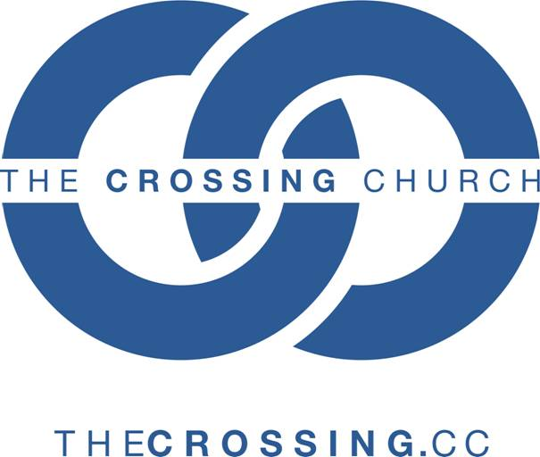
THE CROSSING CHURCH DOCTRINAL STATEMENT

I. THE ESSENTIALS
A) God the Father, Son, and Holy Spirit (The Holy Trinity) ________
We believe the biblical revelation testifies that there is only one God, and that He is eternally
existent in Three Persons: Father, Son and Holy Spirit.
- God The Father - God the Father is the Creator and sustainer of all things and He created the universe, in love, to respond to Him. He created man in His own image for the fellowship and called men back to Himself through Christ after the rebellion and fall of man.
- The Son - Jesus Christ is eternally God. He was together with the Father and the Holy Spirit from the beginning and through Him all things were made. For man's redemption He left heaven and became incarnate by the Holy Spirit of the Virgin Mary; henceforth, He is fully God and fully man.
- The Holy Spirit - The Holy Spirit is God, the Lord and giver of life, who was active in the Old Testament and given to the Church in fullness at Pentecost. He empowers the saints for service and witness, cleanses man from the old nature and conforms us to the image of Christ. The baptism in the Holy Spirit, subsequent to conversion, releases the fullness of the Spirit and is evidenced by the fruits and gifts of the Holy Spirit.
B) The Inspired Scripture: The Holy Bible ________
We affirm that the Bible containing the Old and New Testaments is alone the only infallible
inspired Word of God and that its authority is ultimate, final and eternal. It cannot be added to,
subtracted from, or superseded in any regard. The Bible is the source of all doctrine, instruction,
correction and reproof. It contains all that is needed for guidance in godliness and practical
Christian conduct.
C) Jesus Christ, Our Savior ________
- The Fall of Man - We hold that man is both a physical and spiritual being who is created in God's image. But because of his sin and transgression, man has lost his fellowship with God. The extent of sin is so great that its effects continue to this very day in the form of cruelty, suffering, and death.
- The Atonement - Christ's substantial death on the cross paid the penalty for the sins of the whole world, but its benefits are only applicable to those who receive Jesus as personal Savior. Healing - body, soul, and spirit - is provided for in the atonement as well as of all God's provisions for His saints, and is received by faith.
- Salvation - The Word of God declares clearly that salvation is a free gift of God, based on the merits of the death of His Son, and is appropriated by faith. Salvation is effected by personal repentance, belief in the Lord Jesus (justification), and personal acceptance of Him into one's life as Lord and Savior (regeneration). The new life in Christ includes the privileges of adoption and inheritance in the Kingdom of God's beloved Son. Salvation is an act of free will in response to God's personal love for mankind. It is secure in the eternal, unchanging commitment of God who does not lie and is forever the same. Salvation should produce an active lifestyle of loving obedience and service to Jesus Christ our Savior.
D) The Church ________
We recognize the Church as God's ordained institution, headed by Christ. The church is
composed of all believers and is organized for worship, for fellowship, for the administration of the
sacraments, for spiritual growth and support, and for evangelizing the world. The Church does not
just exist to get people into heaven, but also to train and equip them so that they are complete in
Christ and able to live for Him here on Earth.

II. THE ORDINANCES OF THE CHURCH: BAPTISM AND THE LORD'S SUPPER ________
These two practices were instituted by Jesus when He was on earth and are continued by His church to this day.
- Water Baptism - Simply the outward sign of the inner work god has already done in the individual's life. It is a sign of joining in Christ's death to sin and His resurrection into life in righteousness, as well as a statement to all that the person being baptized now belongs to Christ.
- The Lord's Supper - Done in honor and remembrance of Christ's sacrifice until His return and is a sign of our participation in Him.
III. THE HOLY SPIRIT'S ROLE IN OUR LIVES
- He lives "in" us to comfort and help us. ______
"I will ask the Father, and He will give you another Helper, that He may be with you forever, that is the Spirit of truth, whom the world cannot receive, because it does not see Him or know Him, but you know Him because he abides with you and will be in you."
John 14:16-17 (NASU)
- He teaches us by bringing understanding of the Word. ______
"But the Helper, the Holy Spirit, whom the Father will send in My name, He will teach you all things, and bring to your remembrance all that I said to you." John 14:26 (NASU)
- He convicts of sin. ______
"And He, when He comes, will convict the world concerning sin and righteousness and judgement." John 16:8 (NASU)
- He shapes our character. _______
"But the fruit of the Spirit in love, joy, peace, patience, kindness, goodness, faithfulness, gentleness, self-control; against such things there is no law. Now those who belong to Christ Jesus have crucified the flesh with its passions and desires. If we live by the Spirit, let us also walk by the Spirit." Galatians 5:22-25 (NASU)

- He affirms our acceptance by God. _______
"Because you are sons, God sent the Spirit of his Son into our hearts, the Spirit who calls our, 'Abba, Father.' So you are no longer a slave, but a son; and since you are a son, God has made you also an heir." Galatians 4:6-7 (NIV)
- He empowers us to be witnesses. _______
"But you will receive power when the Holy Spirit has come upon you; and you shall be My witnesses." Acts 1:8a (NASU)
- He empowers us to minister super-naturally by giving us gifts. We receive God's life, love, and favor as each believer uses their God-given gifts to "build up one another." There are two categories of gifts:
  - Motivational Gifts: Qualities of and from God that move us in our thoughts, wants, and feelings; and are graces that minister to one another's needs. _______
"For through the grace given to me I say to everyone among you not to think more highly of himself than he ought to think; but to think so as to have sound judgement, as God has allotted to each a measure of faith. For just as we have many members in one body and all the members to not have the same function, so we, who are many, are one boy in Christ, and individually members of one another. Since we have gifts that differ according to the grace given to us, each of us is to exercise them accordingly: if prophecy, according to the proportion of his faith; if service, in his serving; or he who teaches, in his teaching; or he who exhorts, in his exhortation; he who gives, with liberality; he who leads, with diligence; he who shows mercy, with cheerfulness. Romans 12:3-8 (NASU)
  - Gifts of the Spirit: A supernatural enablement given to believes by the Holy Spirit for the edification of other believers. _______
"Now there are varieties of gifts, but the same Spirit. And there are varieties of ministries, and the same Lord. There are varieties of effects, but the same God who works all things in all persons. But to each one is given the manifestation of the Spirit for the common good. For to one is given the word of wisdom through the Spirit, and to another the word of knowledge according to the same Spirit; to another faith by the same Spirit, and to another gifts of healing by the one Spirit, and to another the effecting of miracles, and to another prophecy, and to another the distinguishing of spirits, to another various kinds of tongues, and to another the interpretation of tongues. But one and the same Spirit works all these things, distributing to each one individually just as He wills." 1 Corinthians 12:4-11 (NASU)

_______________________________________ ______________
Signature Date

